LASER
LASER is an acronym for light amplification by stimulated emission of radiation.

Stimulated Absorption:
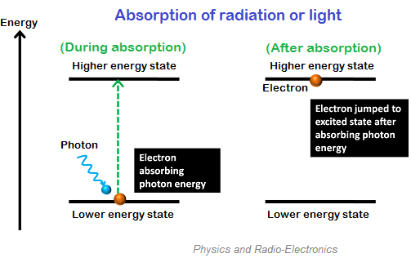
When ground state electrons (E₁) absorb sufficient energy from photons, they jump into the next higher energy level or state (E₂). The electrons in the higher energy level are called excited electrons.
The light or photons energy applied to excite the electrons can be mathematically written as
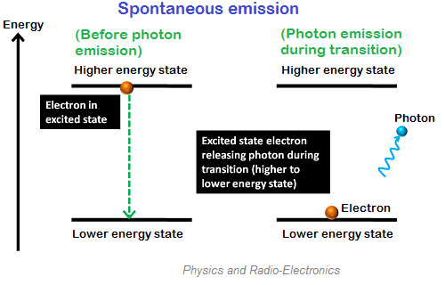
$hϑ=E_{2}-E_{1}$
Where h = Planck’s constant
$ϑ$ = Frequency of photon
E₁ = Lower energy level electrons or ground state electrons
E₂ = Higher energy level electrons or excited state electrons

Spontaneous Emission:
The process by which excited electrons emit photons while falling to the ground level or lower energy level spontaneously is called spontaneous emission.
$hϑ=E_{2}-E_{1}$
The photons emitted due to spontaneous emission do not flow exactly in the same direction of incident photons. They flow in the random direction.

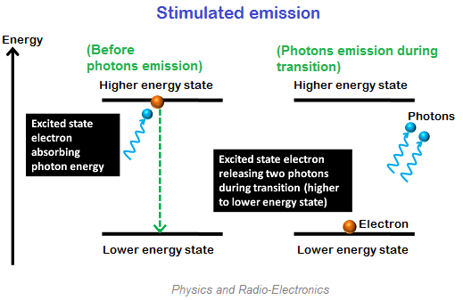
Stimulated Emission:
The process by which electrons in the excited state are stimulated to emit photons while falling to the ground state or lower energy state is called stimulated emission.
$hϑ=E_{2}-E_{1}$
In stimulated emission process, each incident photon generates two photons. All the photons in the stimulated emission have the same frequency and travel in the same direction.

Einstein’s coefficients:
Let N₁ be the number of atoms per unit volume with energy E₁ and N₂ the number of atoms per unit volume with energy E₂.
Let ‘n’ be the number of photons per unit volume at frequency ‘ν’ such that hν = E₂-E₁.
Then the energy density of interacting photons is given by ρ(ν) = nh ν ---------------1
When these photons interact with atoms, both upward (absorption) and downward (emission) transitions occurs. At equilibrium these transition rates must be equal.
Upward transition:
Stimulates absorption rate α N₁
α ρ(ν)
= N₁ ρ(ν)B₁₂ , where B₁₂ is the Einstein coefficient of stimulated absorption.
Downward transition:
Spontaneous emission rate α N₂
= N₂A₂₁, where A₂₁ is the Einstein coefficient of spontaneous emission.
Stimulated emission rate depends on the number of atoms available in the excited state as well as the energy density of interacting photons.
i.e. Stimulated emission rate α N₂
α ρ(ν) ₌ N₂ ρ(ν) B₂₁ , where B₂₁ is the Einstein coefficient of stimulated emission.
For a system in equilibrium, the upward and downward transition rates must be equal and hence we have

N₁ ρ(ν)B₁₂ = N₂ ρ(ν) B₂₁ + N₂A₂₁ -------2

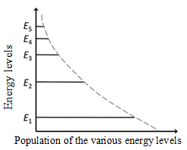
Hence $ρ\left(ν\right)=\frac{N2A21 }{N1B12-N2B21 }$ ------------3

Or $ρ\left(ν\right)=\frac{\frac{A21}{B21}}{\frac{B12N1}{B21 N2}-1}$ --------------------4
The Population of the various energy levels of a system in thermal equilibrium is given by Boltzmann distribution law,

$N_{i}= g_{i}N_{0}exp\left[\frac{-Ei}{kT}\right]$ -----------------------5
Where N_{i} is the population density of the energy level E_{i}. N₀ is the population density of the ground state at temperature T, g_{i} is the degeneracy of the i^{th} level and k is the Boltzmann constant (= 1.38 X 10⁻²³ joule/K).
Hence, $N_{1}= g_{1}N_{0}exp\left[\frac{-E1}{kT}\right]$ and $N_{2}= g_{2}N_{0}exp\left[\frac{-E2}{kT}\right]$

$$\frac{N_{1}}{N_{2}}=\frac{g_{1}}{g_{2}}exp\left[\frac{E_{2}-E_{1}}{kT}\right]$$
$=\frac{g_{1}}{g_{2}}exp\left[\frac{hν}{kT}\right]$ ------------6
Substituting Eq. (6) in Eq. (4),

$ρ\left(ν\right)=\frac{{A_{21}}/{B_{21}}}{\left[\frac{g_{1}}{g_{2}}\frac{B_{12}}{B_{21}} exp\left(\frac{hν}{kT}\right)-1\right]}$ -------------------------------7

from Plank’s law of black body radiation, the radiation density is given by
$ρ\left(ν\right)=\frac{8πhν^{3}}{c^{3}}\left[\frac{1}{\exp\left[\frac{hν}{kT}\right]-1}\right]$ ----------------8
comparing Eq. 7 & 8

$\frac{g_{1}B_{12}}{g_{2}B_{21}}=1$ or g₁B₁₂ = g₂B₂₁ ----------------9

And $\frac{A_{21}}{B_{21}}= \frac{8πhν^{3}}{c^{3}}$ -----------------------10
Eqs. 9 and 10 are referred to as the Einstein relations.

Characteristics of Laser:
The four characteristics of a laser radiation over conventional light sources are
- Laser is highly monochromatic
- Laser is highly directional
- Laser is highly coherent
- The intensity of laser is very high

1. Highly monochromatic:
Band width of a laser light is very low hence it called as high monochromaticity.
The degree of monochromaticity of light is defined in terms spectral width of the source Δλ. This spectral width for a gas discharge line is Δλ = 0.01nm.

2. High directionality:
Laser emits light only in one direction. This is called directionality of laser light. The width of a laser beam is extremely narrow. Hence, a laser beam can travel to long distances without spreading.
The directionality of laser beam is given by (or) expressed in divergence.
The divergence ∆θ = (r₂ -r₁) /(d₂-d₁) Where r₂, r₁ are the radius of laser beam spots and d₂ , d₁ are distances respectively from the laser source. Hence for getting a high directionality there should be low divergence.
3. Coherence:
Lasers are coherent sources. Coherence is of two types,
i) Spatial coherence ii) Temporal coherence
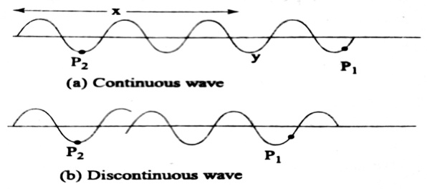
i. Spatial coherence: The two light fields at different point in space maintain a constant phase difference over any time (t) they are said to be spatial coherence or transverse coherence.
When we choose two spatial points P₁ and P₂ on the cross section of the output beam, if they are in phase with one another or maintain same phase differences then they are spatially coherent.
ii. Temporal coherence: The correlation of amplitude and phase between any two points on a wave train over a period of time is called temporal coherence or longitudinal coherence.
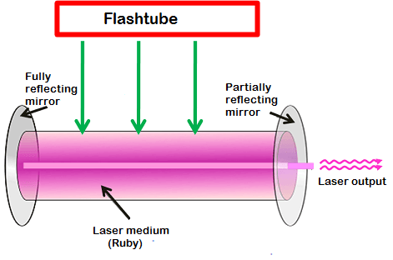
If the two points P₁ and P₂ which are on the same wave train caries same phase and amplitude then it is said to be temporal coherence.
4. High intensity:
Lasers are bright and intense light sources because of coherence and directionality. Intensity of a wave is the energy per unit time flowing through a unit area.

Optical Resonator:
The laser medium is surrounded by two parallel mirrors which provide feedback of the light. One mirror is fully reflective (100 % reflective) whereas another one is partially reflective (<100 % reflective). These two mirrors as a whole is called optical resonator. Optical resonator is also known as optical cavity or resonating cavity.
When energy is supplied to the laser medium, the lower energy state electrons in the laser medium will moves to excited state. After a short period, the electrons in the excited state will fall back to the ground state by releasing energy in the form of photons or light. This process of emission of photons is called spontaneous emission. Thus, light is produced in an active medium by a process called spontaneous emission.
The light generated within the laser medium will bounce back and forth between the two mirrors. This stimulates other electrons to release light while falling to the ground state. Likewise, a large number of electrons are stimulated to emit light. Thus, optical gain is achieved. This amplified light escapes through the partially reflecting mirror. The process of stimulating electrons of other atoms to produce light in the laser medium is called stimulated emission.
Meta stable state: Metastable state is particular excited state of an atom, nucleus or other system that has a longer lifetime than the ordinary excited states and it has generally shorter lifetime than the lowest energy state, called the ground state. A metastable state may thus be considered a kind of temporary energy trap or a somewhat stable intermediate stage of a system where the life time of atom, nucleus or system is in ${10}^{-6} Sec.$
Active Medium:
The laser medium is a medium where spontaneous and stimulated emission of radiation takes place.
After receiving sufficient energy from source, the electrons in the lower energy state or ground state are excited to the higher energy state (in the laser medium) and spontaneous emission will take place. In spontaneous emission, each electron emits a single photon while falling to the ground state.
When these emitted photons collide with the electrons in the excited state or metastable state, it forces metastable electrons to fall back to the ground state. As a result, electrons again release energy in the form of photons. This is called stimulated emission. In stimulated emission, each electron emits two photons while falling to the ground state. When these emitted photons are again interacted with the metastable state electrons then again two photons are emitted by each electron. Thus, millions of photons are generated by using only a small number of photons. Laser medium is also known as active medium or gain medium.

Population Inversion:
The number of atoms in higher energy level is more than the number of atoms in lowest energy level i.e. N₂˃N₁. The process of making of higher population in higher energy level than the population in lower energy level is known as population inversion.
Population inversion is achieved by pumping the atoms from the ground level to the higher energy level.
Pumping Schemes: There are some restrictions are imposed on two level laser system. To overcome such restrictions three and four level laser systems are introduced.
There are different methods of pumping the energy to create population inversion. They are
Optical pumping: In this method, light is used to supply energy to the laser medium. An external light source like xenon flash lamp is used to produce more electrons (a high population) in the higher energy level of the laser medium.
Electrical discharge: In this method of pumping, electric discharge acts as the pump source or energy source. A high voltage electric discharge (flow of electrons, electric charge, or electric current) is passed through the laser medium or gas. This method of pumping is used in gas lasers such as argon lasers.
Chemical reaction: If an atom or a molecule is produced through some chemical reaction and remains in an excited state at the time of production, then it can be used for pumping.
Thermal Pumping: In thermal pumping, heat acts as the pump source or energy source. In this method, population inversion is achieved by supplying heat into the laser medium.
Injection current: Voltage is applied across pn junction diode which injects the charge carriers into p type and n type semiconductors.
Based on the material used to get laser, lasers are classified into three categories. 1) Solid state laser 2) Gases state laser 3) Semiconductor laser.
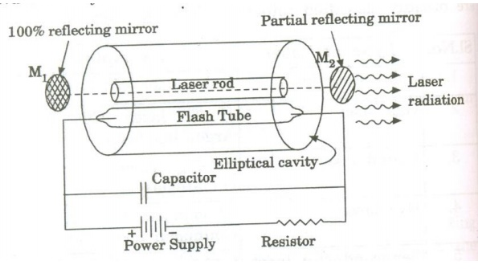
Nd:YAG Laser:
Nd: YAG laser is a neodymium based laser. Nd stands for Neodymium (rare earth element) and YAG stands for Yttrium Aluminum Garnet ( $Y_{3}{Al}_{5}O_{12}$). It is a four level solid state laser.
Principle:
The active medium Nd: YAG rod is optically pumped by Krypton flash tubes. The Neodymium ions (${Nd}^{3+}$) are raised to excited levels. During the transition from metastable state to ground state, a laser beam of wavelength 1.064μm is emitted.
Construction:
The construction of Nd: YAG laser is as shown in the figure . A small amount of Yttrium ions ($Y^{3+}$) is replaced by Neodymium (${Nd}^{3+}$) in the active element of Nd: YAG crystal.
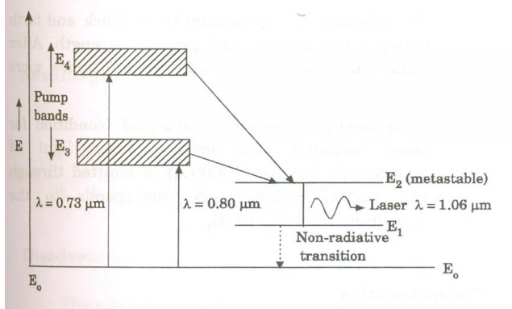
This active element is cut into a cylindrical rod. The ends of the cylindrical rod are highly polished and they are made optically flat and parallel. This cylindrical rod (laser rod) and a pumping source (flash tube) are placed inside a highly (reflecting) elliptical reflector cavity.
The optical resonator is formed by using two external reflecting mirrors. One mirror (M₁) is 100% reflecting while the other mirror (M₂) is partially reflecting.

Characteristics:
Type: It is a four level solid state laser.
Active medium: The active medium is Nd: YAG laser.
Pumping method: Optical pumping is employed for pumping action.
Pumping source: Xenon or Krypton flash tube is used as pumping source.
Optical resonator: Two ends of Nd: YAG rod is polished with silver (one end is fully silvered and the other is partially silvered) are used as optical resonator.
Power output: The power output is approximately 70 watt.
Nature of output: The nature of output is pulsed or continuous beam of light.
Wavelength of the output: The wavelength of the output beam is 1.06μm(infra- red).

Working: Figure shows the energy level diagram for Nd: YAG laser. These energy levels are those of Neodymium (${Nd}^{3+}$) ions.
- When the krypton flash lamp is switched on, by the absorption of light radiation of wavelength 0.73μm and 0.8μm, the Neodymium(${Nd}^{3+}$) atoms are raised from ground level E₀ to upper levels E₃ and E₄ (Pump bands).
- The Neodymium ions atoms make a transition from these energy levels E₂ by non-radiative transition. E₂ is a metastable state.
- The Neodymium ions are collected in the level E₂ and the population inversion is achieved between E₂ and E₁.
- An ion makes a spontaneous transition from E₂ to E₁, emitting a photon of energy h𝜈. This emitted photon will trigger a chain of stimulated photons between E₂ and E₁.
- The photons thus generated travel back and forth between two mirrors and grow in strength. After some time, the photon number multiplies more rapidly.
- After enough strength is attained (condition for laser being satisfied),an intense laser light of wavelength 1.06μm is emitted through the partial reflector. It corresponds to the transition from E₂ to E₁.
Advantages:
1. It has high energy output.
2. It has very high repetition rate operation
3. It is much easy to achieve population inversion.
Disadvantages:
The electron energy level structure of ${Nd}^{3+}$ in YAG is complicated.
Applications:
1. It finds many applications in range finders and illuminators.
2. It is widely used in engineering applications such as resistor, trimming scribing, micro machining operations as well as welding, drilling etc.
3. It finds many medical applications such as endoscopy, urology, neurosurgery, ENT, gynecology, dermatology, dental surgery and general surgery.

He – Ne laser:
Construction: He - Ne gas laser consists of a gas discharge tube of length 80cm and diameter of 1cm. The tube is made up of quartz and is filled with a mixture of Neon under a pressure of 0.1mm of Hg and Helium under the pressure of 1mm of Hg. The ratio of He-Ne mixture of about 10:1.
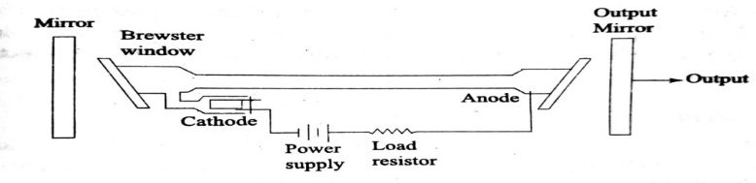
The mixtures is enclosed between a set of parallel mirrors forming a resonating cavity, one of the mirror is completely reflecting and the other is partially reflecting in order to amplify the output laser beam.
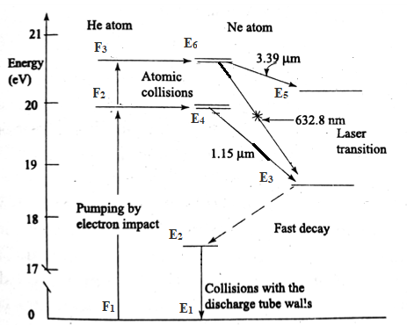
Working: When an electric discharge is passed through the gaseous mixture electrons are accelerated down the tube, these accelerated electrons collide with the helium atoms and excite them to higher energy levels ( F₂ and F₃) since the levels are meta stable energy levels of He. He atoms spend sufficiently long time and collide with Neon atoms in the ground level E₁ . Then Neon atoms are excited to the higher energy levels E₄ & E₆ and helium atoms are de excited to the ground energy level.
Since E₄ & E₆ of Ne atom are metastable states, population inversion takes place at these levels. The stimulated emission takes place between E₆ to E₃ gives a laser light of wavelength 632.8nm (6328A⁰) and the stimulated emission between E₆ and E₅ gives a laser light of wave length 3.39µm. Another stimulated emission between E₄ to E₃ gives a laser light of wave length 1.15µm. The Neon atoms undergo spontaneous emission from E₃ to E₂ and E₄ to E₂. Finally the Neon atoms are returned to the ground state from E₂ by non-radeative diffusion and collision process. After arriving at the ground state, once again the Neon atoms are raised to E₄ & E₆ by excited Helium atoms thus we can get continuous output from He-Ne laser.

Molecular Gas Laser
In a molecular gas laser, laser action is achieved by transitions between vibrational and rotational levels of molecules. Its construction is simple and the output of this laser is continuous.
In ${CO}_{2}$ molecular gas laser, transition takes place between the vibrational states of Carbon dioxide molecules.
${CO}_{2}$Molecular Gas Laser
It was the first molecular gas laser. It is a four level laser and it operates at 10.6 μm in the far IR region. It is a very efficient laser.
Principle:
The active medium is a gas mixture of ${CO}_{2}$, $N_{2}$ and He. The laser transition takes place between the vibrational states of ${CO}_{2}$molecules.
Construction:
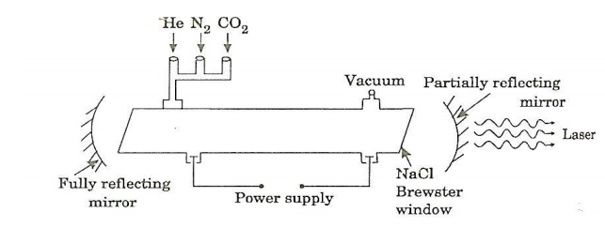
It consists of a quartz tube 5 m long and 2.5 cm in the diameter. This discharge tube is filled with gaseous mixture of ${CO}_{2}$ (active medium), helium and nitrogen with suitable partial pressures. The terminals of the discharge tubes are connected to a D.C power supply. The ends of the discharge tube are fitted with NaCl Brewster windows so that the laser light generated will be polarized. Two concave mirrors one fully reflecting and the other partially form an optical resonator.
Working:
Figure shows energy levels of nitrogen and carbon dioxide molecules.
When an electric discharge occurs in the gas, the electrons collide with nitrogen molecules and they are raised to excited states. This process is represented by the equation
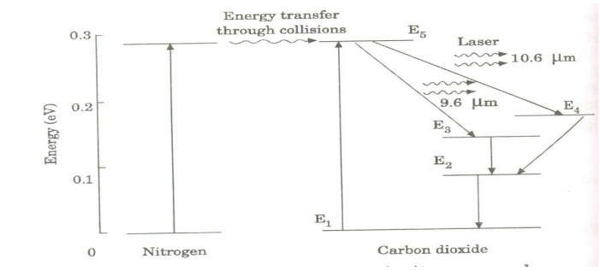
$N_{2}$ + e* = $N_{2}^{*}$ + e
$N_{2}$ = Nitrogen molecule in ground state e* = electron with kinetic energy
$N_{2}^{*}$ = nitrogen molecule in excited state e = same electron with lesser energy
Now N₂ molecules in the excited state collide with ${CO}_{2}$ atoms in ground state and excite to higher electronic, vibrational and rotational levels.
This process is represented by the equation $N_{2}^{*}$ + ${CO}_{2}$= ${CO}_{2}^{*}$ + $N_{2}$
$N_{2}^{*}$ = Nitrogen molecule in excited state. ${CO}_{2}$ = Carbon dioxide atoms in ground state ${CO}_{2}^{*}$ = Carbon dioxide atoms in excited state $N_{2}$ = Nitrogen molecule in ground state.
Since the excited level of nitrogen is very close to the E₅ level of ${CO}_{2}$ atom, population in E₅ level increases.
As soon as population inversion is reached, any of the spontaneously emitted photon will trigger laser action in the tube. There are two types of laser transition possible.
- Transition E₅ to E₄ : This will produce a laser beam of wavelength 10.6μm
- Transition E₅ to E₃: This transition will produce a laser beam of wavelength 9.6μm. Normally 10.6μm transition is more intense than 9.6μm transition. The power output from this laser is 10kW.
Characteristics:
- Type: It is a molecular gas laser.
- Active medium: A mixture of ${CO}_{2}$ , $N_{2}$ and helium or water vapour is used as active medium
- Pumping method: Electrical discharge method is used for Pumping action
- Optical resonator: Two concave mirrors form a resonant cavity
- Power output: The power output from this laser is about 10kW.
- Nature of output: The nature of output may be continuous wave or pulsed wave.
- Wavelength of output: The wavelength of output is 0.6μm and 10.6μm.
Advantages:
- The construction of ${CO}_{2}$ laser is simple
- The output of this laser is continuous.
- It has high efficiency
- It has very high output power.
- The output power can be increased by extending the length of the gas tube.
Disadvantages:
- The contamination of oxygen by carbon monoxide will have some effect on laser action
- The operating temperature plays an important role in determining the output power of laser.
- The corrosion may occur at the reflecting plates.
- Accidental exposure may damage our eyes, since it is invisible (infra red region) to our eyes.
Applications:
- High power ${CO}_{2}$ laser finds applications in material processing, welding, drilling, cutting soldering etc.
- The low atmospheric attenuation (10.6μm makes ${CO}_{2}$ laser suitable for open air communication).
- It is used for remote sensing.
- It is used for treatment of liver and lung diseases.
- It is mostly used in neuro surgery and general surgery.
Types of Semiconductor Diode Lasers:
Broadly there are two types of semiconductor diode lasers. They are
(i) Homojunction Semiconductor Laser
(ii) Heterojunction Semiconductor Laser
Homojunction Semiconductor Laser:
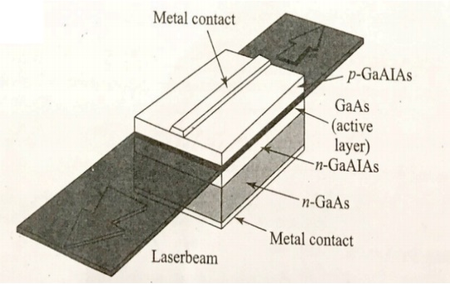
A simple diode laser which makes use of the same semiconductor material on both sides of the junction is known as a homojunction diode laser.
Example: Gallium arsenide (GaAs) laser.
(a) Construction:
- Starting with a heavily doped n-type GaAs material, a p-region is formed on its top by diffusing zinc atoms into it.
- The diode is extremely small in size. Typical diode chips are 500 μm long and about 100 μm wide and thick.
- The top and bottom faces are metallized and metal contacts are provided to pass current through the diode.
- A pair of parallel planes cleaved at the two ends of the PN junction provides the required reflection to form the cavity.
- The two remaining sides of the diode are roughened to remove lasing action in that direction.
- The entire structure is packaged in small case which looks like the metal case used for discrete transistors.
b) Working:
- Heavily doped p- and n- regions are used. Because of very high doping on n-side, the donor levels are broadened and extend into the conduction band.
- The Fermi level is pushed into the conduction band and electrons occupy the levels lying below the Fermi level.
- Similarly, on the heavily doped p-side the Fermi level lies within the valence band and holes occupy the portion of the valence band that lies above the Fermi level.
- At thermal equilibrium, the Fermi level is uniform across the junction.
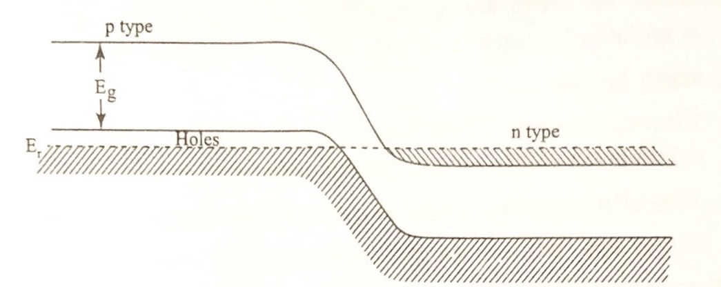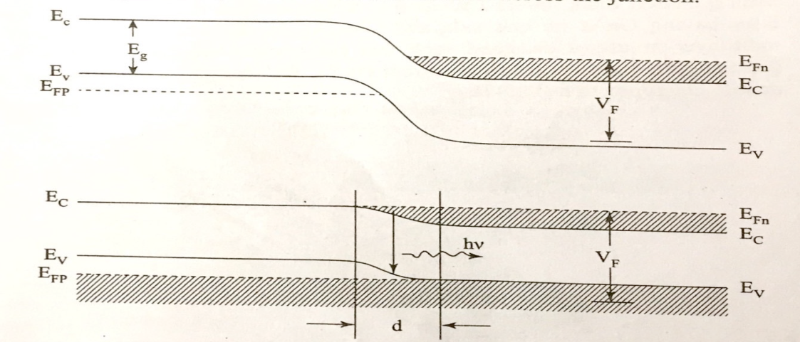

(c) Pumping Mechanism
- When the junction is forward-biased, electrons and holes are injected into the junction region in high concentrations.
- When the diode current reaches a threshold value, the carrier concentrations in the junction region will rise to a very high value.
(d) Population inversion
- The region ‘d’ as shown in Fig. contains a large concentration of electrons within the conduction band and simultaneously a large number of holes within the valence band.
- The upper energy levels in the narrow region are having a high electron population. while the lower energy levels in the same region are vacant. It creates the condition of population inversion and is called an inversion region or active region. room temperature.
(e) Lasing action
- Chance recombination leads to emission of spontaneous photons which stimulate the conduction electrons to jump into the vacant states of valence band.
- This stimulated electron-hole recombination produces coherent radiation
- GaAs laser emits light at a wavelength of 9000 A in IR region.
(f) Drawbacks of homojunction lasers:
- The active region is not well defined due to the diffusion length of the carriers.
- The semiconductor has nearly uniform refractive index throughout. Therefore, light can diffuse from active layer into the surrounding medium. As a result the cavity losses increase.
- High threshold currents are required and the laser cannot be operated continuously at

Applications of Lasers:
Because of these unique properties, lasers are used in various applications.
The most significant applications of lasers include:

Lasers in Medicine:
- Lasers are used for bloodless surgery.
- Lasers are used to destroy kidney stones.
- Lasers are used in cancer diagnosis and therapy.
- Lasers are used for eye lens curvature corrections.
- Lasers are used in fiber-optic endoscope to detect ulcers in the intestines.
- The liver and lung diseases could be treated by using lasers.
- Lasers are used to study the internal structure of microorganisms and cells.
- Lasers are used to produce chemical reactions.
- Lasers are used to create plasma.
- Lasers are used to remove tumors successfully.
- Lasers are used to remove the caries or decayed portion of the teeth.
- Lasers are used in cosmetic treatments such as acne treatment, cellulite and hair removal.

Lasers in Communications:
- Laser light is used in optical fiber communications to send information over large distances with low loss.
- Laser light is used in underwater communication networks.
- Lasers are used in space communication, radars and satellites.

Lasers in Industries:
- Lasers are used to cut glass and quartz.
- Lasers are used in electronic industries for trimming the components of Integrated Circuits (ICs).
- Lasers are used for heat treatment in the automotive industry.
- Laser light is used to collect the information about the prefixed prices of various products in shops and business establishments from the bar code printed on the product.
- Ultraviolet lasers are used in the semiconductor industries for photolithography. Photolithography is the method used for manufacturing printed circuit board (PCB) and microprocessor by using ultraviolet light.
- Lasers are used to drill aerosol nozzles and control orifices within the required precision.

Lasers in Science and Technology:
- A laser helps in studying the Brownian motion of particles.
- With the help of a helium-neon laser, it was proved that the velocity of light is same in all directions.
- With the help of a laser, it is possible to count the number of atomsin a substance.
- Lasers are used in computers to retrieve stored information from a Compact Disc (CD).
- Lasers are used to store large amount of information or data in CD-ROM.
- Lasers are used to measure the pollutant gases and other contaminants of the atmosphere.

Lasers in Military:
- Laser range finders are used to determine the distance to an object.
- The ring laser gyroscope is used for sensing and measuring very small angle of rotation of the moving objects.

